.1

**CAREER OBJECTIVE:**

I enjoy being challenged and engaging with projects that require me to work outside my comfort and knowledge set, as continuing to learn new languages and development techniques are important to me and the success of my organization.

.

.

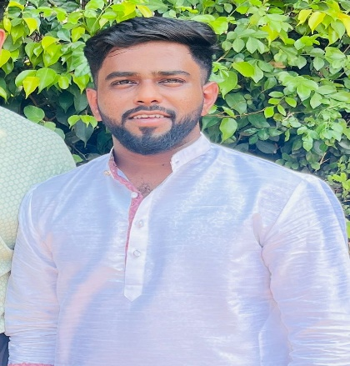

**Address:**   
Chaudhari nagar, dhanori , , Pune 411015

**Phone:**

+91 8308106771

**E-Mail:**

Aj626781@gmail.com

# Languages

English

Hindi

Marathi

**Academic Qualifications**

* B.Com

Modern college of cmmerce.

* CBSE (2018)

Kendriya Vidyalaya, Pune.

* CBSE (2016)

Kendriya Vidyalaya, Pune.

Hobbies:

Cricket

Swimming

**Summary**

* I am a Results-ori

ANIKET JADHAV

**Work Experience:**

* One year 10 months of experience as a Associate Team Member in insurance Domain.

**Project:**

1. **Escrow Payment Process:**

* Calculate claim related payments**.**
* Customer profile maintenance.

1. **Refund Plus:**

* Balance Transfer through cheque.
* Validating payments related details

**KEY SKILLS:**

* Good Communication
* Good in EXCEL
* Ability to Lead The Team
* Problem Solving Ability
* Hard and Smart Worker

Here by I declare that the above information is correct and authentic to best of my knowledge.

**Aniket Jadhav.**

Here by I declare that the above information is correct and authentic to best of my knowledge.

**Aniket Jadhav.**